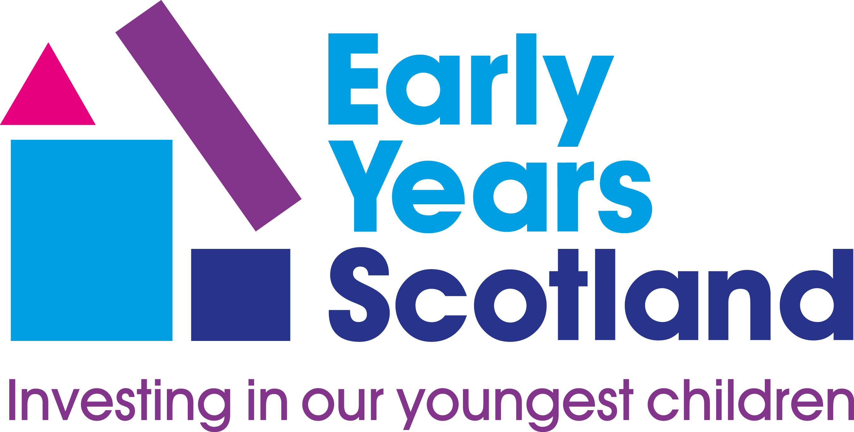

This Hame Fae Hame policy was prepared in February 2021.
Tracking Children’s Progress

This policy was adopted at a meeting of:
Hame Fae Hame

On 3/2/2021…………………………………..

Signed …………Kaye Sandison……………………..….….. Designation ………….…………Manager………………

Statement of Purpose
As an Early Education and Childcare (ELC) setting we aim to provide a high quality service for both children and parents. We recognise the value of monitoring and tracking children’s progress. By monitoring children’s strengths and areas for development next steps in learning can be identified. Continuity of learning is vital to ensure all children reach their full potential and that their individual needs are met. Tracking children’s progress allows us to provide appropriate support and monitor the impact on the progress and development of the child.
Throughout the policy the term parents is used to include all main care givers.

Observations for Assessment
By observing children we can build up knowledge which allows us to understand their development and growth. Observations help us to plan a curriculum that is valuable and has breadth and depth for all learners. Planning children’s experiences and learning intentions is an on going process and assessment information gathered will be shared to plan future learning experiences. Observation is at the heart of our work with children and observations will be carried out formally and/or informally, specifically and/or continuously. Information will be gathered in a variety of ways including observations, self assessment and peer assessment and will be shared with relevant professionals and parents as appropriate. When observing children the most suitable method(s) of observation should be chosen to ensure the relevant information is gained. Depending on the aim of the observation will determine the method chosen. Methods of observation include Time Sampling, Target Child, Frequency Sampling, Duration Sampling and Diaries (this is not an exhaustive list). Children present us with a variety of opportunities to learn more about them and by observing them we can understand how best to meet their needs.

Using Observations and Assessments
Our observations and assessments will provide information and feedback for all relevant stakeholders including children, parents, staff and other professionals. Children will be at the heart of the assessment process as we support them to become reflective learners, able to evaluate their own progress and use this evidence to inform their choices. Staff will work in partnership with children, parents and other professionals as relevant, making effective use of a range of assessments to inform future learning and to identify progress made. We will ensure that all staff involved in this process have a very good understanding of child development and early learning pedagogy.
Staff will use observations and assessments in conjunction with their knowledge of the developing child to identify supports for children who may need them and then to assess the effectiveness of these supports. The assessment process will also identify children who require to be challenged in their learning and to plan appropriate programmes for them. Supporting and challenging children in this way will help us ensure learner engagement and development built around the individual child.
Information from observations and assessments will help inform our evaluations of the
curriculum on offer and the effectiveness of our learning and teaching strategies. This will enable strategies to be put in place to support learning, enhance our practice and ensure progress. The information will also help us ensure that the curriculum offers breadth and depth and that all children are developing as successful learners, confident individuals, responsible citizens and effective contributors.
Reliable continuous information gathered from observations and assessments will allow us to: recognise, capture and celebrate achievements; profile children's learning and progress; report on this at various transition points such as home to setting, movement through the various stages within the setting and transfer to primary school. While ensuring that all aspects of the child's learning and development are taken into consideration, progress in communication, early language, mathematics and health and wellbeing will form a key part of the observation, assessment and reporting cycle.

Recorded Evidence of Progress
The setting will keep records of children's progress to support the processes outlined above. This evidence will take the form of daily diaries/record sheets for our youngest children and folios for older children. Children and parents will be encouraged to contribute to and make decisions on what is included in these folios. While these records will be kept up to date by the child's key person, we recognise the value of shared information from other members of the staff team in order to form an accurate assessment of the child's progress.
The setting will produce reports at relevant reporting stages. These will include at least bi-annual reports to parents on their child's progress, reports to assist smooth movement between stages within the setting and a transition record for parents and receiving primary school.
Children's diaries, records and folios will also be used to assist educational psychologists, speech therapists and any other relevant professional in their assessment of a child as appropriate.
Alongside observations and assessments of children, Big Books and other curriculum planning and recording tools will be used to assess the collective effectiveness of the curriculum.
We aim to fully involve parents in their child's learning and development and will take their views and information of successes beyond the setting into consideration when making assessments and compiling reports on children.

Monitoring of this Policy
It will be the responsibility of Kaye Sandison to ensure that all staff, including new or temporary staff, are familiar with this policy and to monitor that it is being implemented. Monitoring and evaluation of the policy will be achieved by all staff continuously reflecting on and evaluating their practice. This will be monitored through our planning and assessment material and will be reviewed regularly to assess impact. The monitoring of children’s folios will be ongoing to ensure all information is relevant and up to date. Staff training records and practice will be monitored to ensure that staff knowledge of child development and learning and early learning pedagogy is current and reflected in all aspects of practice

See also:
Additional Support For Learning Policy
Child Protection Policy
Curriculum Policy
Responsive Care Policy
Promoting Positive Behaviour Policy
Self Evaluation Policy
Transitions Policy

Links to national policy:
National Care Standards 4,5,6 7,10,11,12

http:www.nationalcarestandards.org/213.html

https://education.gov.scot/improvement/Pages/frwk1hgioearlyyears.aspx
(How good is our early learning and childcare? HGIOELC)

http://www.gov.scot/Resource/0045/00458455.pdf
(Building the Ambition, Scottish Government 2014)

http://www.educationscotland.gov.uk/earlyyears/prebirthtothree/index.asp

http:www.educationscotland.gov.uk/learningandteaching/earlylearningandchildcare/curriculum/index.asp
(Curriculum for Excellence, Scottish Government)

Find out more:
http://www.educationscotland.gov.uk/learningandteaching/earlylearningandchildcare/index.asp
Education Scotland (Early Years)

